EXPERIMENTAL FIELD TRIP: Friday Sept. 27th
Toronto Biennial of Art, Kensington market, and MOCA
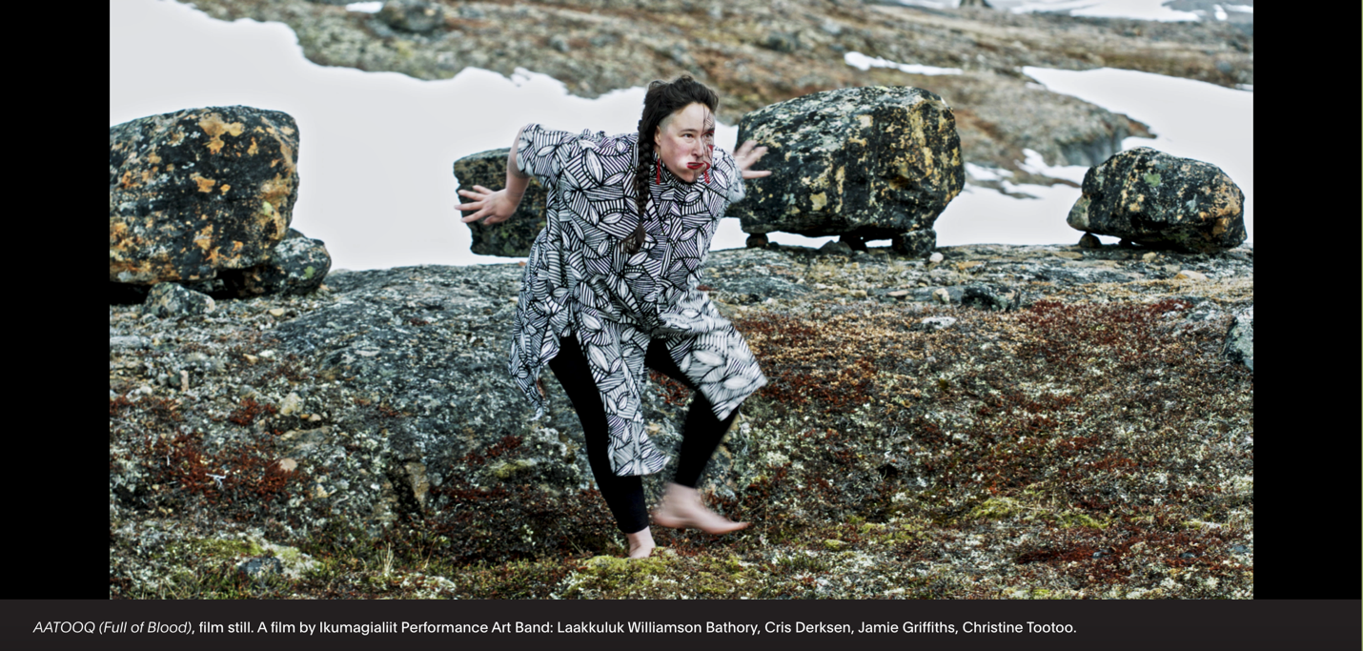
See exhibition details:
Toronto Biennial of Art
Museum of Contemporary Art
9:30am: (9:45) Leaving Guelph University bus loop to drive to Toronto
11am: Arrive at 32 Lisgar St.
Noon: Leaving Lisgar St.
12:30: Arrive at Kensington Market for lunch
1:45 Leave Kensington Market
2:15: Arrive at Auto Building at 158 Sterling Road, 9th Floor and
MOCA museum (18 and under are FREE, $10 for students over 18)
(Guided tour at 2:30 – 3:15)
4:15: Bus departs Sterling Rd and returns to Guelph Bus loop.
(Approx) 6pm: Arrives in Guelph University bus loop

